In 8th grade, I took *Geometry*

Shapes in a Rectangular Grid

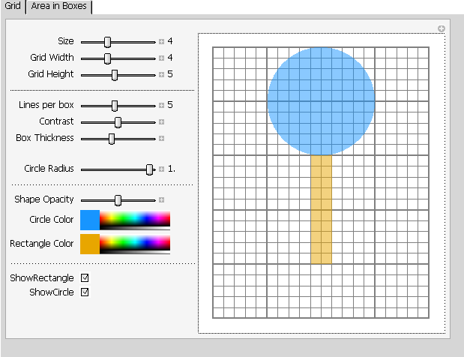

The area of a shape, or a combination of shapes, is fundamentally explained as the total area of many small units that make up the shape/shapes, like the squares on the grid.

I already knew that the area of the lollipop was 20+25π, or around 99.

I did learn something in that class, however –

Shapes in a Polar Grid

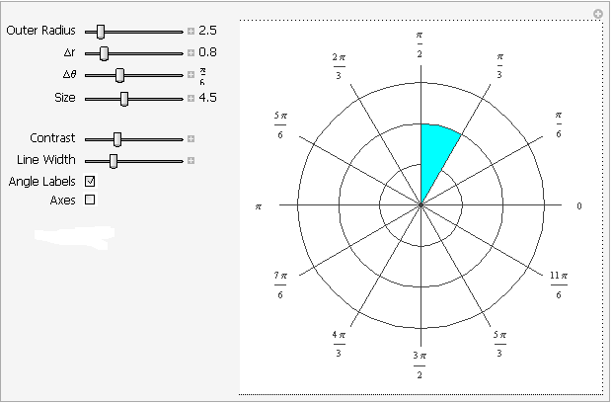

The polar coordinate system is a different way of seeing the world. Points are defined in terms of an angle (usually from the x axis), and a distance from the origin.

I leaned that a circle’s equation is r = 6, and that a slice goes from π/3 to π/2.